SVI Area’s Training Team for Guiding Connections 2024
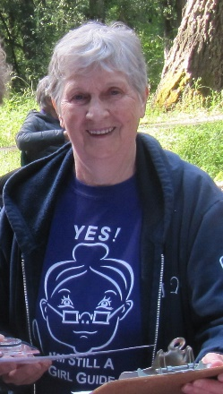
Araina: Long time Guider formerly Guides and Pathfinders in Raven and Pacific Skies Districts.
Guiding Connections sessions: “Building Unit Guider Skills – Guides” and “Games for Guides & Pathfinders”

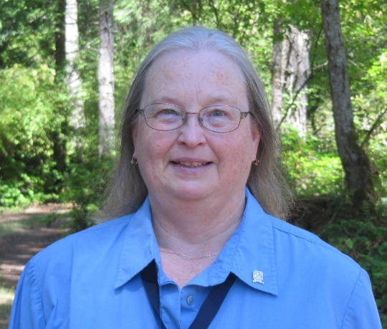

Brenda: Long time Guider formerly Guides in Woodwyn District.
For Guiding Connections: registration, logistics, Trainer and Guider support

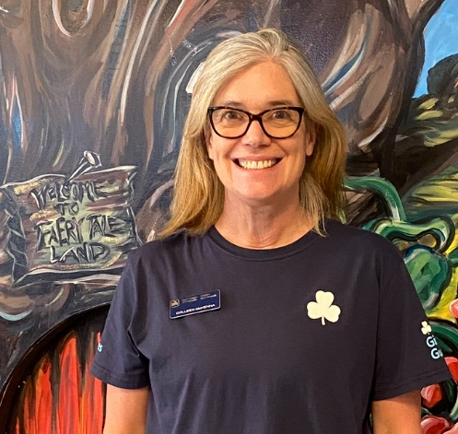
Colleen: Currently with Sparks in Raven District and she is Provincial Commissioner in her spare time!
Guiding Connections session: “Building Unit Guider Skills- Sparks”

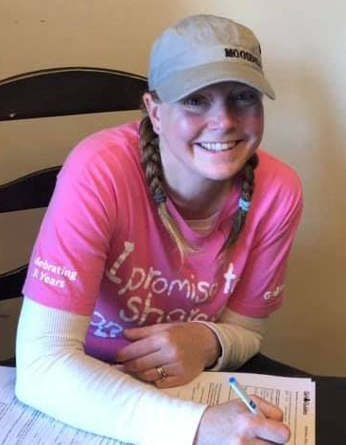

Cynthia: Cynthia is the DC for Harbours District and a Guider with Harbours Guides & Pathfinders & Pacific Skies TREX.
Her Guiding Connections session: “STEM for Units”
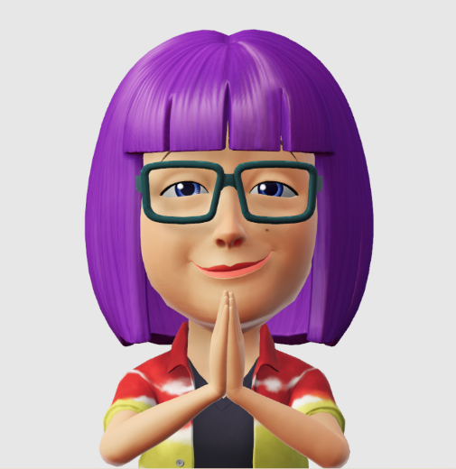
Jill: Decades of Guiding experience as a youth and adult member. Favourite branch to work with is Pathfinders. Claim to fame: part of a team that ran 13 PJ sewing sessions at Guiding Mosaic 2006 with 60 participants in each workshop.
Guiding Connections sessions: “Building Unit Guider Skills - Pathfinders & Rangers” and “Planning a Spark/Ember Sleepover” and “Safe Guide Refresher”

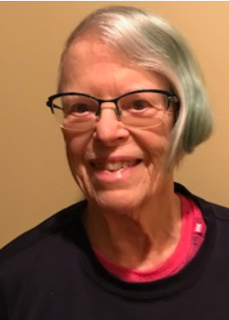

Sheila: Long time Guider, Crafter & Quartermaster. Currently with Sparks in Bay to Bay District.
Guiding Connections sessions: “Building Unit Guider Skills- Sparks” and “Kitchens & QM for Camp” and “Program Crafts for Sparks/Embers”

Tiffany: (Photo not available)
Currently with Guides in Pacific Skies District, formerly Embers in Lakes District.
Guiding Connections sessions: “Building Unit Guider Skills- Embers” and “Games for Guides & Pathfinders”

