
BOWKER HALL (est.1957) - SOUTHERN VANCOUVER ISLAND AREA
1709 Monterey Ave, Victoria, BC V8R 5V6

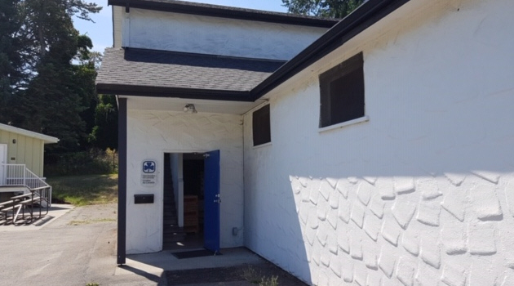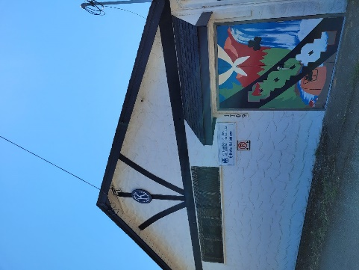
MAIN ENTRANCE OUTSIDE EXIT DOORS

Bowker Hall is located in Oak Bay at 1709 Monterey Avenue. The hall is next door to Fireman’s Park, the Scout Hall, and the municipal police and fire stations. We are the building closest to the baseball park.
Driving time to Bowker Hall is about 10 minutes from downtown Victoria, and about 45 minutes from the Swartz Bay ferry terminal. To reach the hall by bus, please see www.bctransit.com/victoria
Things to do within the neighbourhood
- Fireman’s Park  - Oak Bay Recreation Centre (pool & showers)  - Willows Beach  - Oak Bay Marina  - Gonzales Hill Park  - Uplands Park | - Fairways grocery store  - Art galleries on Oak Bay Avenue  - Kiwanis Willows Beach Tea Room (Summer)  - Greater Victoria Public Library-Oak Bay Branch  - Centennial Trail  - Anderson Hill Park

Things to do in downtown Victoria
- BC Legislature  - Royal BC Museum  - IMAX Theatre  - Inner Harbour  - Empress Hotel  - Beacon Hill Park  - Emily Carr House  - Dallas Road waterfront | - Ogden Point Breakwater  - Fisherman’s Wharf  - Chinatown  - Shopping on Government Street and Lower Johnson  - Bay Center  - Craigdarroch Castle  - Victoria Art Gallery

Further Distance
- Butchart Gardens
- Point Ellice House
- Whale Watching
- Zipline adventures at WildPlay or Adrena Line
- University of Victoria
- Mt. Tolmie or Pkols for beautiful views of Victoria

SUPPLIED/NOT SUPPLIED – see forms provided upon booking for more details
- Supplied – toilet paper, floor cleaner, toilet cleaner, coffee filters, bathroom paper towel, dish soap
- Not Supplied – all consumables – food (including seasonings, sugar), bleach, dish cloths, tea towels, paper towels, potholders, foil, flashlights, First Aid kit, rubber gloves, SOS pads, oven cleaner, compost bags and garbage bags, hand sanitizer, sanitizing spray, anti-bacterial wipes, food wrap
- No landline phone
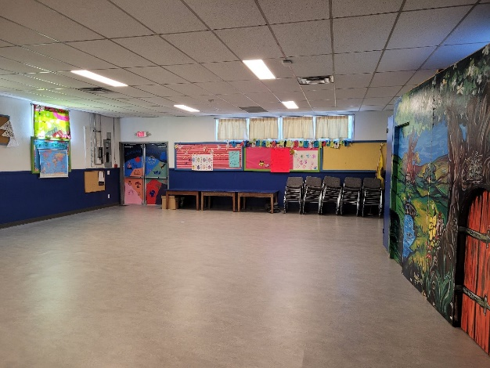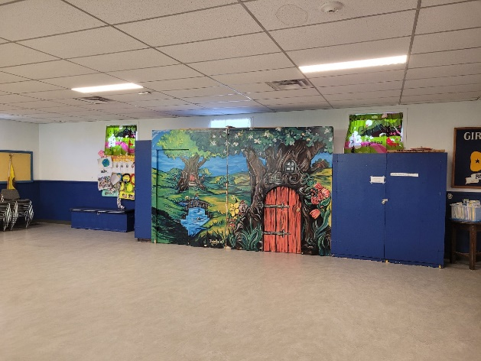
MAIN FLOOR
- Sleeping, eating and activities are accommodated in the large hall with an additional small meeting room upstairs
- Washroom facilities but no showers.
- Maximum overnight capacity is 24 people (youth & adults)
- Free parking available for a maximum of 2 vehicles in the “Loading Zone” area in front of the main entrance between noon on Fridays until 8:00am on Mondays. All other vehicles must park on Monterey Avenue. The Oak Bay Fire Department runs daily training, Monday to Friday mornings from 8:00am-Noon when there is no parking allowed by the public in the whole parking lot during that time frame. Summer rentals and day use rentals, please be aware of this restriction. If there are mobility concerns, please connect with the Bowker Hall Manager ggcbowker@gmail.com.
- Free WiFi
- Audio Visual equipment available

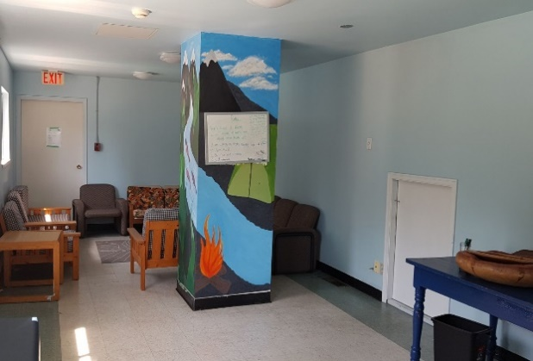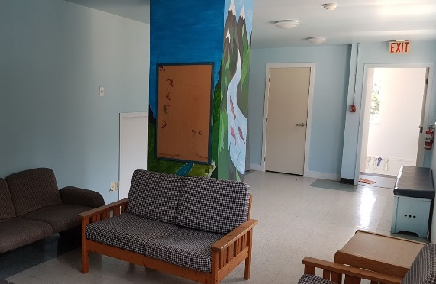
UPSTAIRS

- Fully equipped kitchen with dishes and cutlery, cooking utensils, fridge, stove, dishwasher, microwave, toaster, kettle & coffee maker
- Recycling, garbage & compost must be taken with you unless you are travelling by bus or from across the border and have made prior arrangements with the Bowker Hall Manager ggcbowker@gmail.com to leave your garbage and recycling.

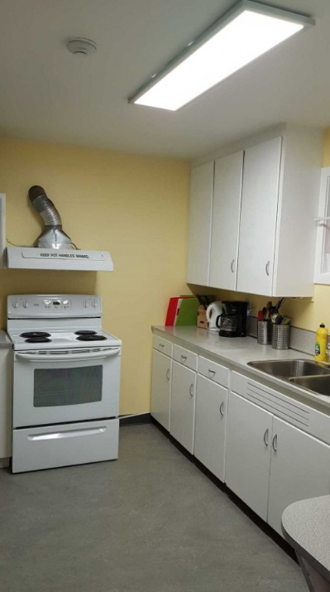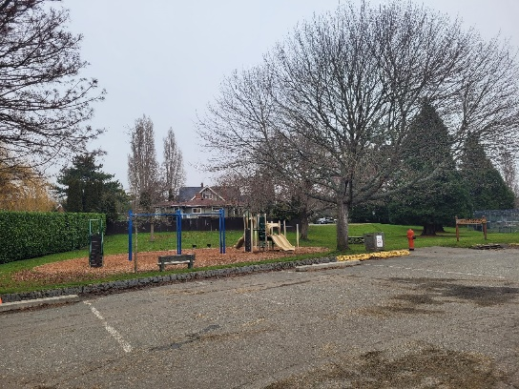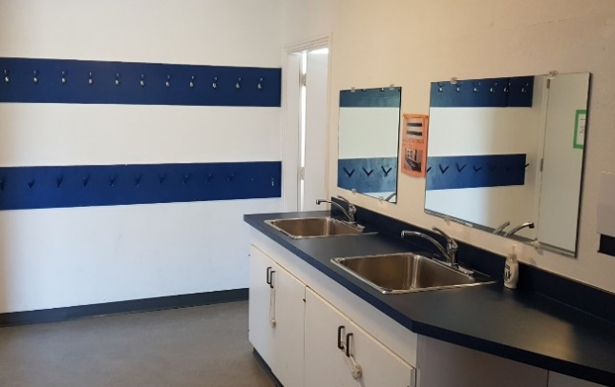

KITCHEN PLAYGROUND SINKS NEAR MAIN ENTRANCE

- Crests are available to purchase from a basket in the kitchen for $3.00 each. Payment must be made at the same time as rental payment, please do not leave cash or cheques at the hall.

