PROGRAM CRAFTS FOR SPARKS AND EMBERS
Area Training Day March 9th, 2024
First, let’s define crafts
- 3D
- Can take home
- Not (usually) done in groups
- When I asked for craft ideas, I got lots, but many of them I consider activities. Which are great fun and necessary for a unit, and certainly have program connections, but are not crafts
- Examples: baking, team projects with recycling (we made marble runs), science experiments
  - All fun but not crafts!

There is always somewhere to fit your crafts into program, it just sometimes requires some wiggling
- Can always go into art studio – especially if the craft requires some creativity
  - Not as much if it’s a peel-and-stick, so…
- Think about what skill or area it is related to. There is ALWAYS the Unit’s Own option!
  - Using new equipment or materials? How to
  - Representing themselves? Being You
  - Everyday items? Life Stuff
- The Unit Experience Compass recommends 1-2 creative activities per month
  - That means you don’t have to craft every week!
- Every group is different, but they will also start to like what you offer
  - So if you don’t want to do crafts, you do not have to force yourself into crafts!
- They are, however, a great opportunity to expand everyone’s comfort, ability, and skills
- Psst…anytime we make a trader (a small craft that can be hung on a hat), we talk about traders, and we give them a spirit of guiding activity
So, let’s get crafty!
- Beaded butterflies (see attached instructions)
  - 3 pipecleaners, ton of beads
  - Usually we do these as friendship butterflies – make two, trade one
  - Have also done them with penpals
  - Will keep kids entertained for 30+ minutes!
- Body in a bag
  - Team activity so we can invite discussion
  - Science/Being You
  - My FAVOURITE activity (though definitely more of an activity than a craft) (but can still hang on their hat!)
  - Creative thinking – what else can you use to represent body parts?
  - I use (everything small):
    - Pink sponge – brain
    - Water balloons x2 - lungs
    - Paper heart – heart
    - Red yarn and blue yarn tied together – veins and arteries
    - Elastic band – muscles
    - Stick (small dowel, popsicle stick, toothpick) – bones
    - Googly eyes – eyes
    - Beans - kidneys
    - Bag to hold it all - skin

- The “dumb bird thing”
  - Ongoing joke because my co-Guider (who is also my mum) thought this was the silliest thing when I first made it in Sparks
  - I loved it to pieces until it did eventually, mysteriously, disappear
    - She claims innocence. We all know she’s not innocent
  - We always wind the kids up about it: “Rainbow thinks this craft is silly but it’s Giggles’ FAVOURITE EVER”
    - it’s always a hit
    - (and they’re always on my side)
  - They have been:
    - Just dumb bird things (Sparks in History/Spirit of Guiding)
    - Comets (science)
    - Dragons (paper bag princess)
    - Science of sound (different sounds we can make)
    - Birds (nature discovery)
    - What can we use to make them? Used to be film canisters, then test strip containers, now…any ideas?
    - Can always give a nature discovery because these are OUTSIDE toys ONLY
  - I do not have a picture so:
    - SUPPLIES:
      - Small containers (test strip/film canister/pill bottles)
      - One long piece ribbon or string
      - Several long pieces survey tape
      - Decorations for outside of container
    - Decorate as desired
    - Place ribbon and survey tape with one end inside. Ribbon/string on opposite side to survey tape
    - Put lid on, ensuring ribbon and tape have lots sticking out
    - Use the ribbon to swing the bird around! Test patterns, sounds, string lengths, and speed!

- Reef knot paracord (one long piece of paracord, tie a reef knot, then can be pinned onto sash or hat)
  - Spirit of Guiding
  - How to
  - Life stuff
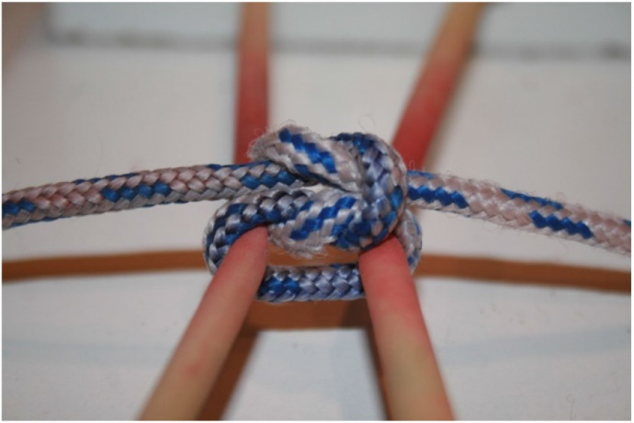

- Cupcake fish
  - Rainbow fish story tie-in
  - Being You/Different together

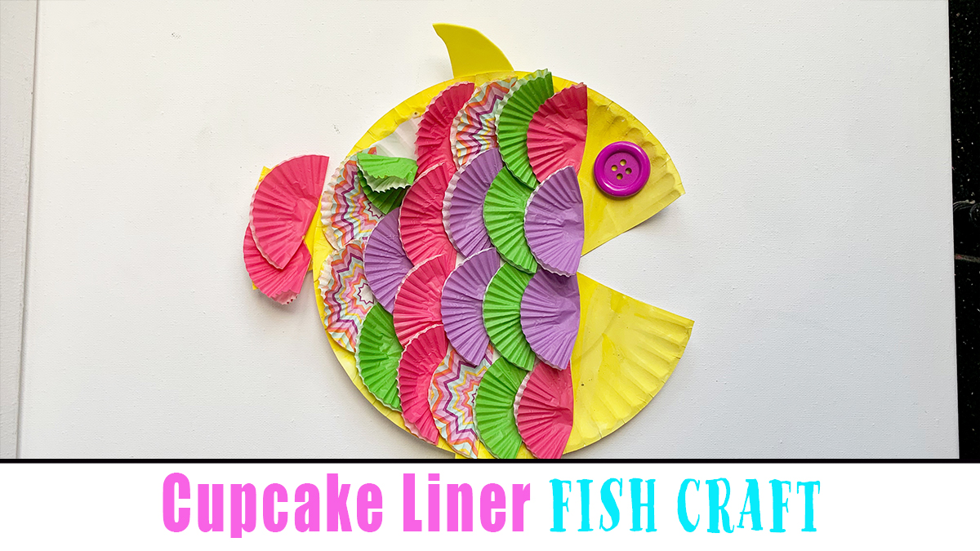

- Button poppy
  - Canadian connections, how to
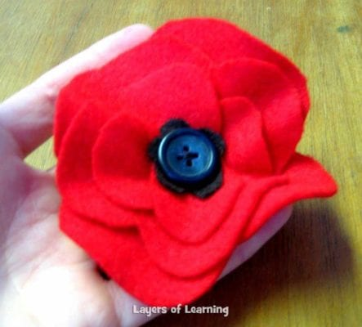

- This little guiding light of mine
  - Jars, tissue paper glue on containers, etc
  - Thinking Day/Spirit of Guiding
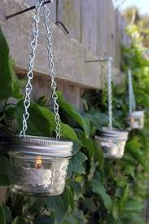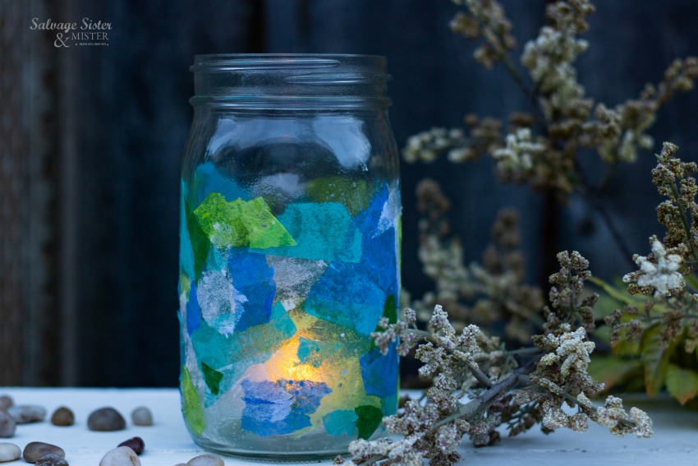
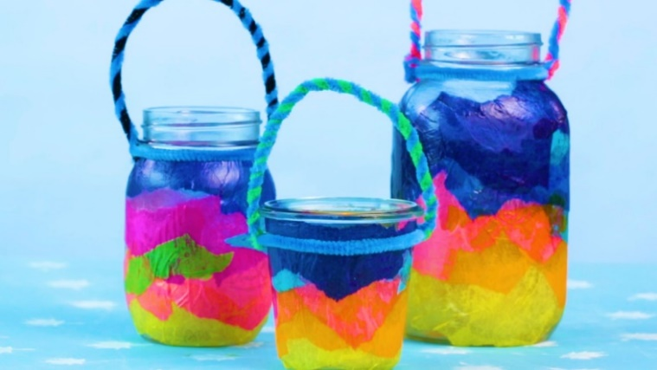

- Guiding rainbow
  - Clouds
  - Ribbon wheels
  - Teach about colour/science, different branches, form groups
  - Can fit into a bunch of places!
  - Can also make ribbon sticks with the same method then dance with them – my physical self
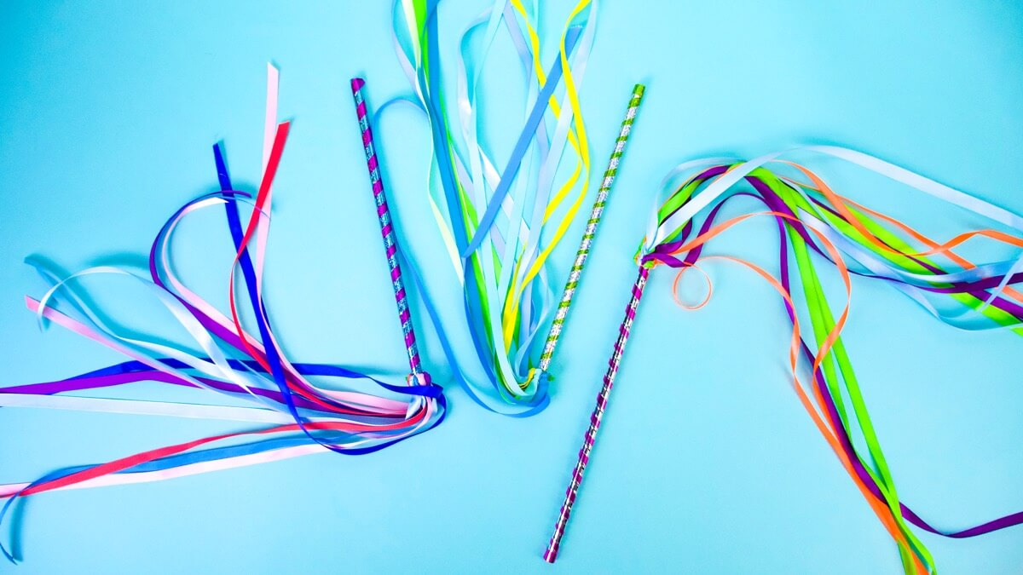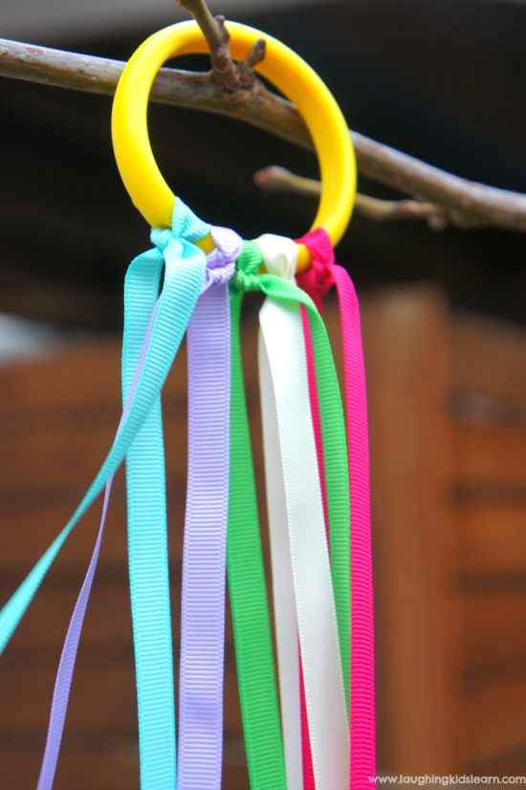
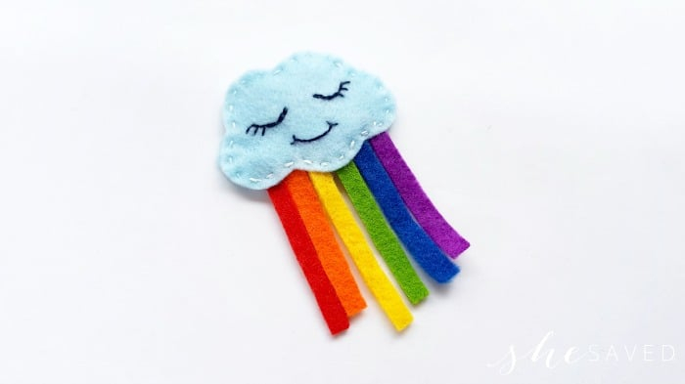
(One cloud sticky felt, one side normal felt; ribbon pieces in guiding colours; stick them to the sticky side, fold if desired, press normal felt onto sticky one so ribbons are sandwiched between)

- Pipe Cleaner trefoil
  - Picture trefoils (spirit of guiding/our story)
  - Also can be used for friendship and to talk about the importance of the trefoil
  - Also a great trader
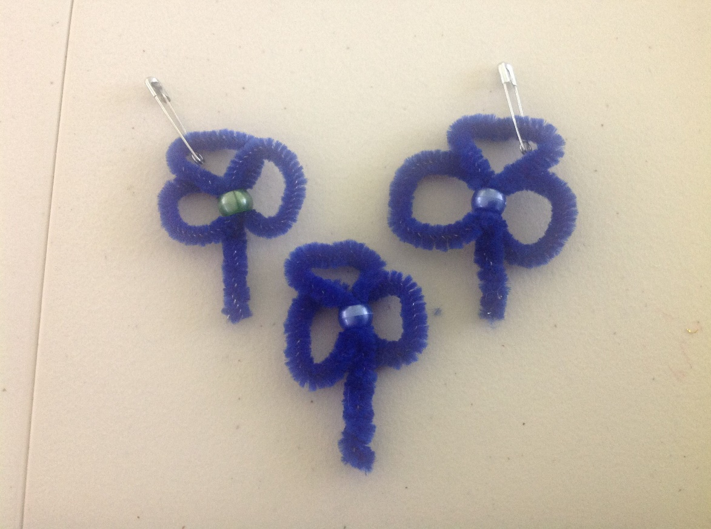

- Shrinky dink
  - Can theme it any way you want
  - Then science of heat
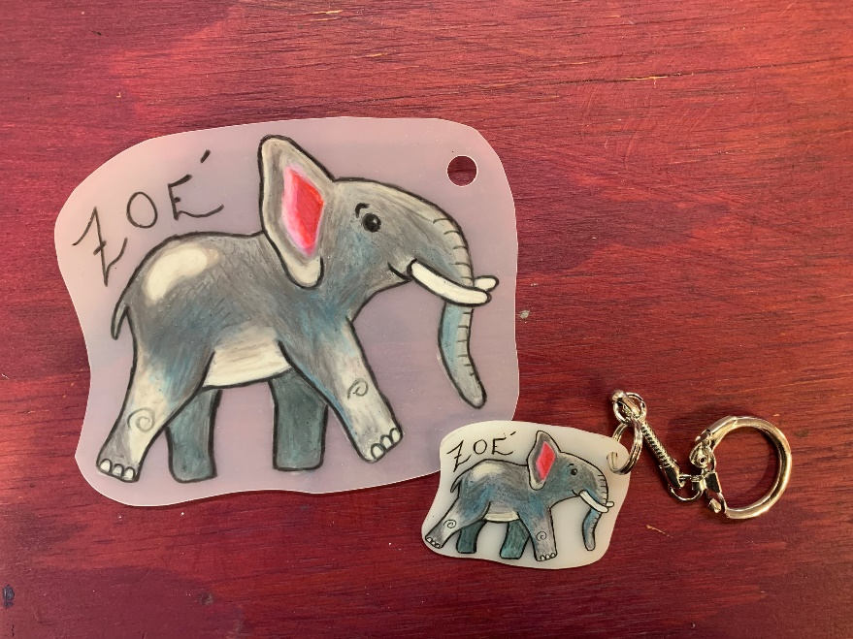

- Woodland picture frames
  - Requires dry sticks and a LOT of hot glue
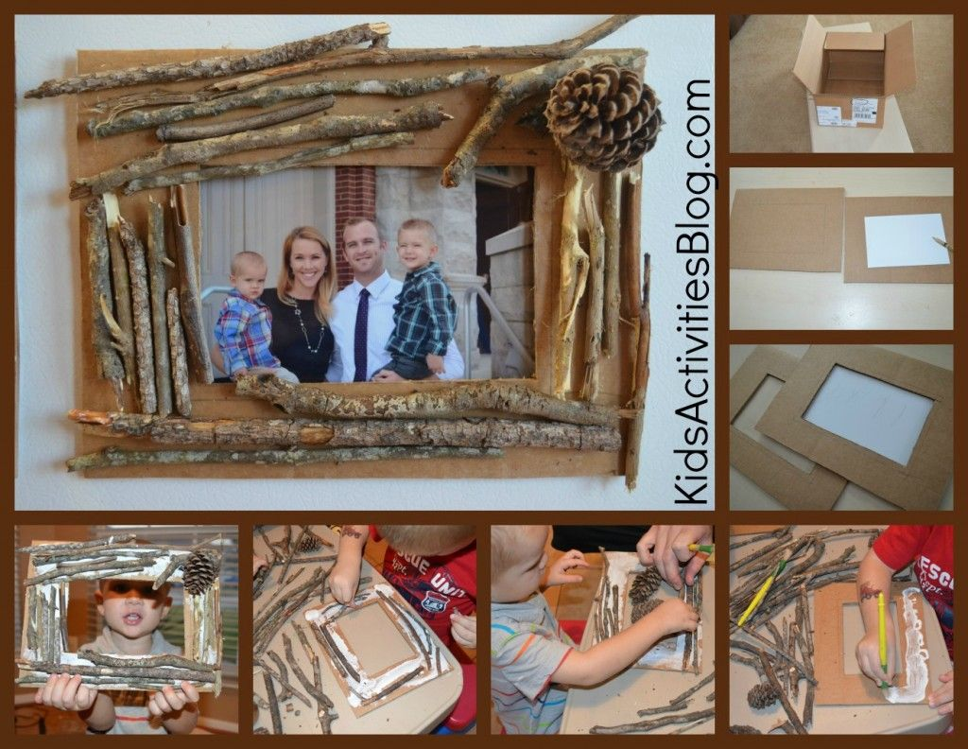

- Money boxes (money sense)
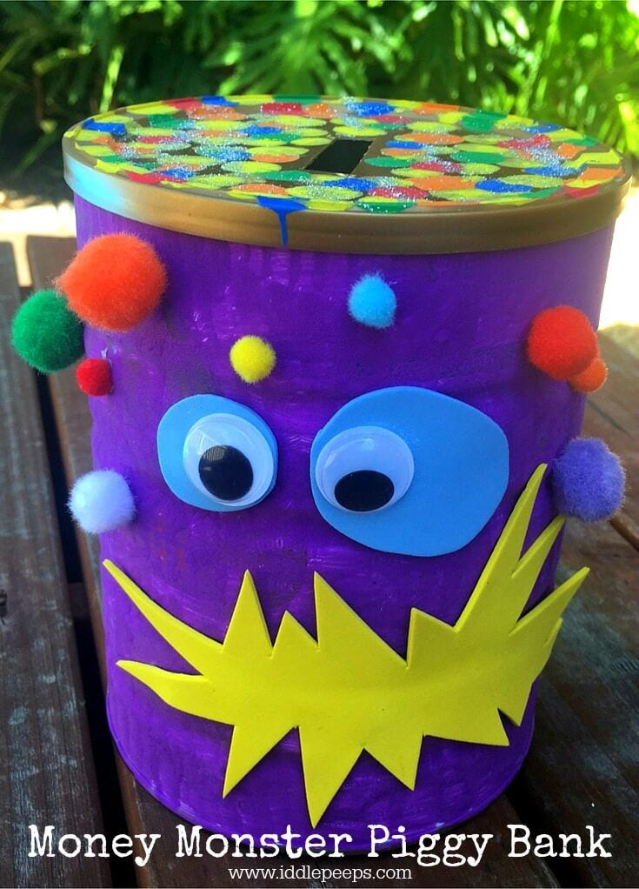
  - Tea canisters (we drink a lot of Tetley), decorate them like monsters, always cute

- Wearables of any kind
  - Fit into any theme
  - Collaborate with the theme if it’s program, or spirit of guiding if it’s simply celebratory
  - Art studio has a unit’s own as well!
  - Flower crowns, animal ears, princess crowns, fish headbands, woodland creature headbands, jungle animals…

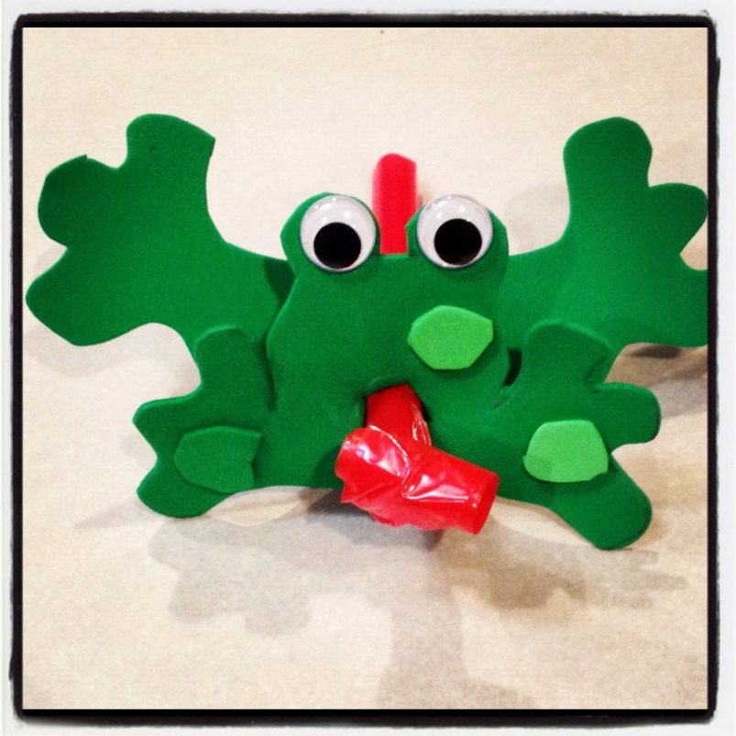
- Blowy frogs
  - Little green frog song

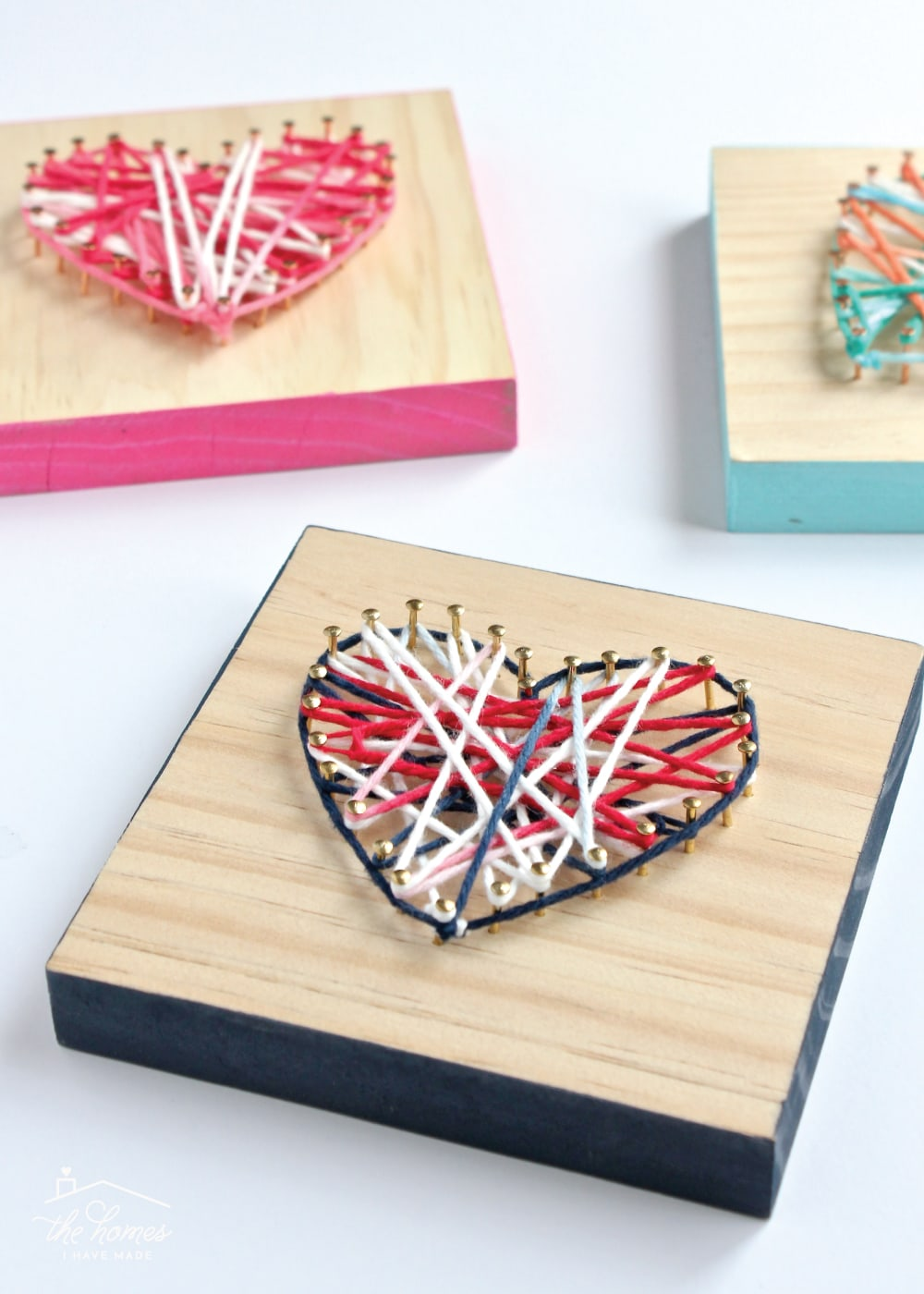
Yarn art (they can screw the screws)
  - How to
  - Tool matching
  - Lots of prep work
  - Cannot speak to the success of it with Sparks

Building toothbrush robots
  - https://www.sciencebuddies.org/stem-activities/toothbrush-bristlebot
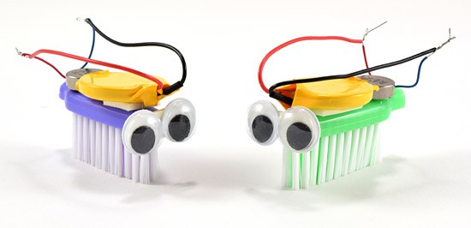
Have never made them but always wanted to! Great science and design space activity!

