KINGSWOOD CAMP - SOUTHERN VANCOUVER ISLAND AREA
611 Linnet Lane, Victoria, BC
Kingswood Camp is set in a beautiful wilderness setting close to hiking trails, recreation centre and a lake for swimming or canoeing. McKevitt Lodge is available for Indoor camping and daytime events. Two tenting sites are available for outdoor camping and events.

MCKEVITT LODGE
Nestled into the woods above Elk Lake, this charming lodge is ideal as an indoor camp for any level of Guiding or any group up to 30. Day use may have up to 60.

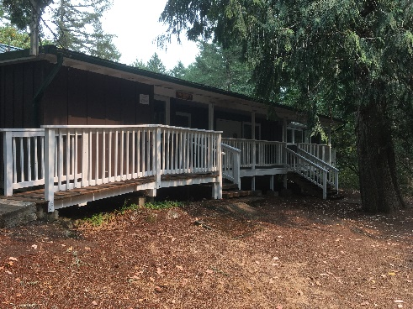 | 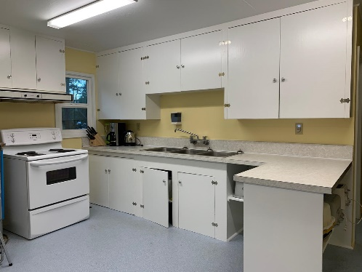 | 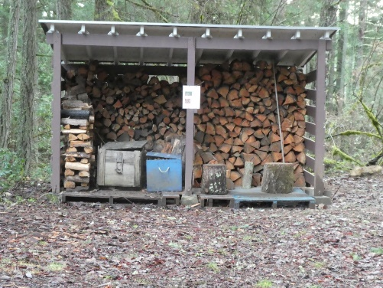

LODGE FEATURES:
- 24 bunks (with mattresses)
- Large, fully equipped kitchen
- Central room equipped with tables and chairs
- Heat and hot water (no showers)
- Large open grass area in front for active games
- Nearby fire ring with benches (wood fires Oct. 16 to April 30 only)
- Wheelchair accessible
SUPPLIED/NOT SUPPLIED
- Supplied – toilet paper, floor cleaner, toilet cleaner, hand soap
- Not Supplied – all consumables – food, dish soap, bleach, dish cloths, towels, paper towels, foil, garbage bags, oven mitts, flashlights, First Aid kit. Effective September 2021 campers are to provide their own personal sit-upons (covid protocol). There is no landline phone at Kingswood Camp.

FREEMAN KING SITE
Surrounded by majestic Arbutus and Garry Oak, this site has a wheelchair accessible outhouse and can accommodate 30 people. Lovely at any time, it becomes filled with wildflowers in Spring. This site is conveniently located next to the Kory Marshall Trail.

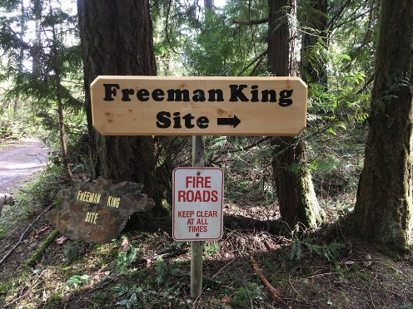 | 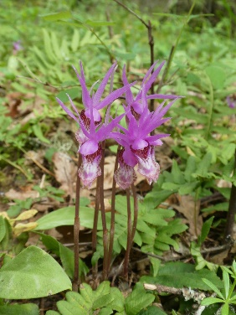 | 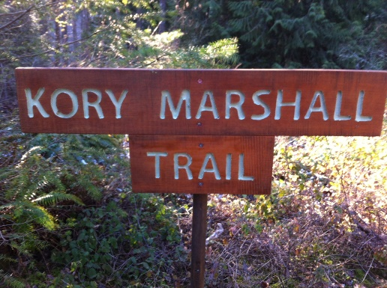

Campsite features:
- Cook shelter with wood stove
- Tent sites in trees
- Potable running water at shelter and liquid disposal unit for waste water
- Large fire ring for group campfires (wood fires Oct. 16 to April 30 only)
- 4 outdoor latrines with 2 wheelchair accessible

BILL REITH SITE
This site can accommodate 30 people. It features a wide open field area for activities and a flattened tenting area with a large fire ring for group campfires. This site is conveniently location next to the Elk/Beaver Lake Park trail.

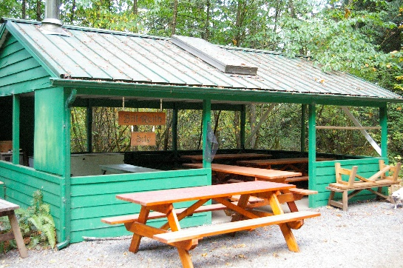 | 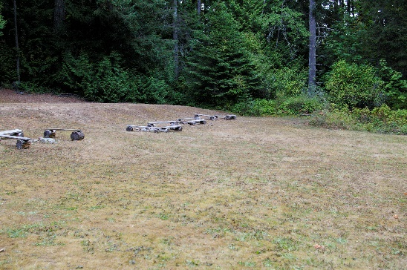 | 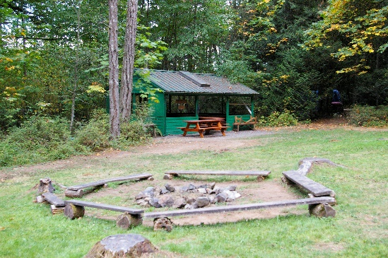

Campsite features:
- Cook shelter with wood stove
- Tent sites on raised flat grass area
- Potable running water at shelter and liquid disposal unit for waste water
- Large fire ring for group campfires (wood fires Oct. 16 to April 30 only)
- 3 outdoor latrines

OTHER AMENITIES
- CANOES – SVI Area owns several canoes that available to rent, with all paddles and safety equipment provided. More information here: https://www.svigirlguides.bc.ca/canoe-rentals-kingswood
- PROPANE FIRE PITS – groups must bring their own propane tanks.
- ORIENTEERING COURSE
- CRESTS AVAILABLE FOR PURCHASE - $3.00 each

BOOKING PROCEDURE – Visit https://www.svigirlguides.bc.ca/camp-booking-information
Upon confirmation of your booking you will receive further details about the camp, including arrangements for obtaining keys, paying your deposit and your fees. The deposit will be deducted from your camp fee total if you leave the site clean and secure and everything in good repair. Details of camp rental rates and subsidies for SVI Area members are at https://www.svigirlguides.bc.ca/camps
Kingswood camp crests

