SVI Girl Guide
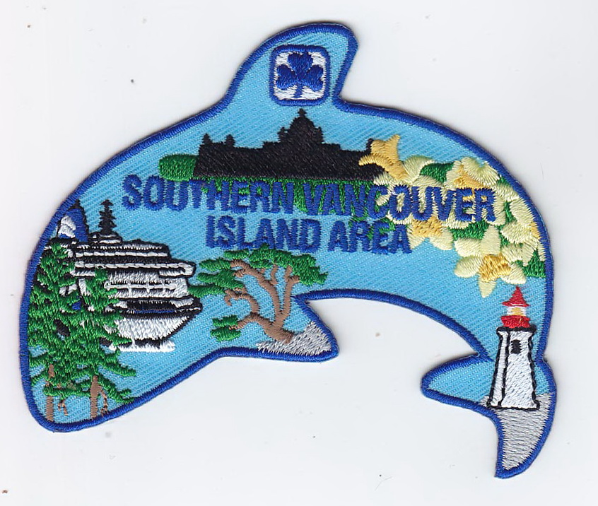
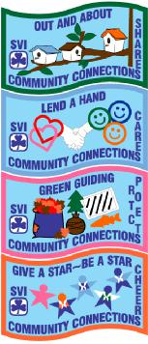
Community Connections Challenge
Crest Order Form

Congratulations on earning a Community Connections Challenge Crest
Section completed (please, use a separate sheet for each section):
- Out and About (green)
- Lend a Hand (blue)
- Green Guiding (pink)
- Give a Star – Be a Star (orange)
Unit / Guild or Individual Name:_____________________________________
Contact Information: Phone: _____________ Email:___________________
Address: ______________________________________________________
Number of Challenge Crests needed:______________
These will be mailed to the address above.
(above for SVI members ONLY – for members outside SVI Area please contact SVI Area at svigirlguides@shaw.ca for crest pricing and shipping information)
Include the completed evaluation form for the section earned with digital pictures, if possible (ensure the members involved have a YES on the IR.1 and that you have permission from non-guiding persons) and return to :

SVI Area: 611 Linnet Lane, Victoria, BC V9E 2B1
or email to svigirlguides@shaw.ca

GOOD LUCK ON COMPLETING ALL FOUR!
For Office Use only:
Evaluation form fully completed Yes No More info needed Yes No
Pictures Included: Yes No Date received: _________________
Date crests distributed: ____________________________

