SVI Area Rentals

Item | Weekly Rental | SOAR Rental | Out of Area
Unit Rentals

9 Garmin GPS units with rechargable batteries and 2 chargers  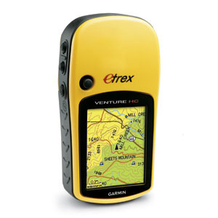 | $10 for all the units plus chargers. | N/A | Available for out of Area rentals with a deposit cheque made out to Girl Guides of Canada SVI Area at $120/unit. Regular rental fees apply.
8 Cobra Handheld Radios with chargers  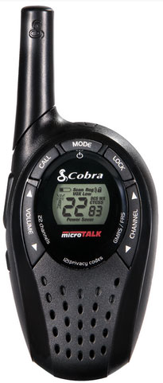 | $10 for all the units and chargers/week. | N/A | N/A
Canoes  Not exactly as pictured.  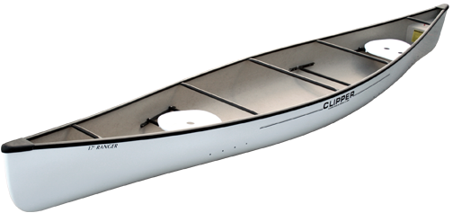 | Please check with SVI Properties Bookings for current rates.  Available at Kingswood only. | N/A | Available at Kingswood Camp Only. Please book through SVI Area Properties.
Cambro 5 gal Hot or Cold Drink Dispenser  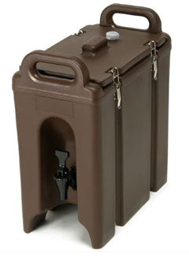 | Available for District or Area Use Only  Must Be Returned Clean and Dry | N/A | N/A

Portable Sound System (not exactly as pictured)  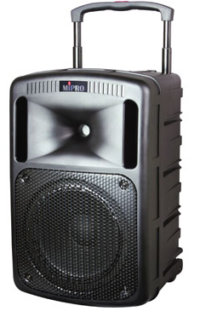 | Available for District or Area Use Only  Must be returned with microphone and all cords in tidy order  Deposit $50 | N/A | N/A

Area Use Only

Event Tent similar but not exactly as pictured, with 3 velcro walls and clear vinyl sign holder  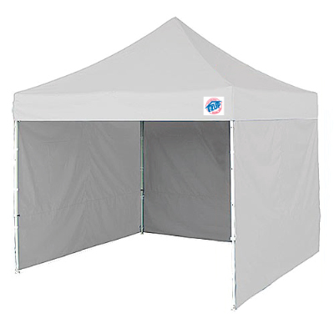 | Available for Area use only.  Not to be used for QM or Food Preparation Area | Not Allowed. | N/A
2 Portable Charcoal Barbeques  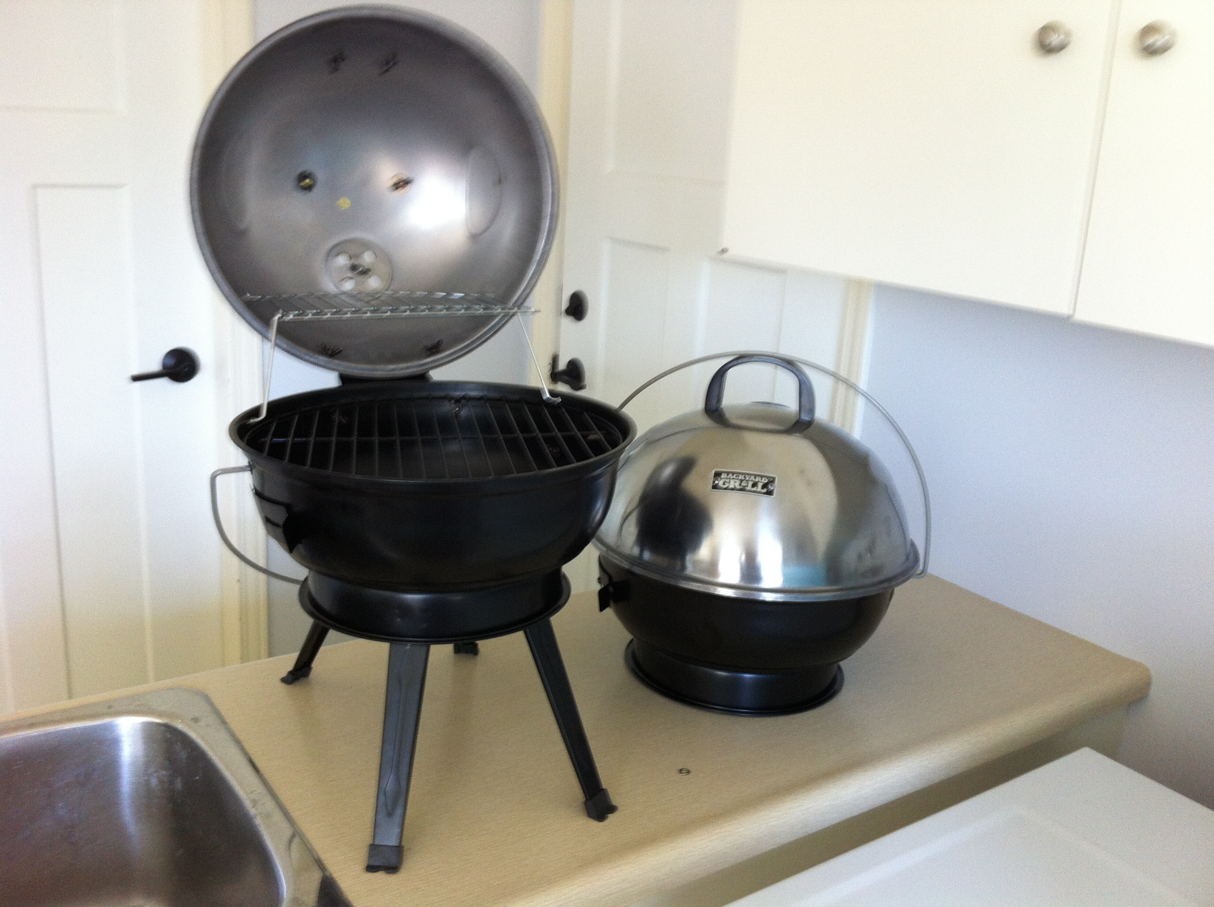 | Available for Area use only.  Please run grates through dishwasher before returning. | N/A | N/A
All deposits and fees are payable to: Girl Guides of Canada SVI Area

