Discover SVI Camps Challenge (Revised February 2023)
The Discover SVI Camps Challenge was created in 2011 to encourage members of Southern Vancouver Island Girl Guides to get to know our camp properties better. Each of the three challenges will run until the supply of crests is exhausted. There is a charge of $2/crest to help offset the cost of the crests. There are three camps on Southern Vancouver Island where the challenge is available, two with tenting sites and one residential.

- Camp Jubilee is 160 acres near the community of Shirley, BC. There are two salmon bearing creeks and two main tenting areas with dining shelters, outhouses, water tank, fire-pits and storage buildings for some camp equipment. There is an additional camping area often used by small groups or for overflow from camps based at one of the other sites. Most of the property is undeveloped forest. A box of challenge materials is available on site in the Kirby panabode. (Look on small shelf to the left of the door.)

- Milne’s Landing is a 10 acre property near Sooke, BC. The lower part of the property is on the Sooke River Estuary. There are two full facility lodges with bunks.

- Kingswood Camp is 25 acres near Elk/Beaver Lakes, Saanich, BC. The lower end of the property is fenced and borders the public walking trail that circles the two lakes. There is one full facility lodge and two main tent areas with dining shelters, taps with potable water, outhouses and fire-pits. Laminated challenge maps and information is located in the sign-in kiosk.

There are several challenge components to achieve at each of the sites.

- Sleep at the camp 2 consecutive nights
- Camp Skill
- Site History
- Ecosystem/Nature
- Guiding component (songs/skits/stories)

Once you have completed the challenge return the completed form with a picture of your unit to the SVI office. Crests will be mailed out to you. There is a cost of $2/crest. Please note units may not request extra crests. The number of crests requested and the number of participants in your photograph should match (minus the photographer of course). Payment for crests is done through Unified Banking – unit to Area.

GPS units for units wishing to access the geocaches located on all three properties are available through the Area Camping Adviser. Rental on the units is $10 for all 9 units per weekend or week.

Camp Jubilee Challenge – Bridges, Kirby or Gateway Site
Recommended for Guide age and older

Prior to Camp: Contact the SVI Camp Properties Bookings to obtain a short list of possible simple service projects.

At Camp:
- Sleep in tents for a minimum of two consecutive nights at Camp Jubilee. Girls should sleep in a tent with their patrol.
- With your tent team, or other group of up to 6 girls, put on a skit for the rest of the campers about a piece of history of the site. Leaders do a skit too! There is a small booklet to read in the challenge box located in Kirby panabode.
- Cook at least one entire meal using something other than a propane stove as your heat source. Some possibilities are: fire, tin-foil dinners, cooking on sticks, dutch oven, solar, box oven, buddy burner or lightweight stove for hiking. Small patrol fires along the rocky creek beds off of “BRIDGES” & “KIRBY” sites are popular. Don’t forget to totally dismantle them when finished. You may use a propane stove to heat water for washing dishes. Check the BC Girl Guide Site under the Camping Resources tab for some great ideas.
- Describe in writing or draw 5 terrestrial plants growing on Camp Jubilee property, then identify them.
- The laminated map of Camp Jubilee has two points marked on the map: “A” and “B”. Using only GPS and/or compass directions and distances, write instructions to get from “A” to “B” for someone who does not have a map to use.
- Do a minimum of 15 minutes of camp service each in addition to jobs already required and listed on the check-out form.
- In 2009 fish habitat was improved in hopes of increasing the survival rate of young fish living in the creeks on the GGC property before they return to the sea. Ponds were created to the left of the gate as you enter the camp and near the “GATEWAY” dining shelter. What do these improvements provide for the fish and how do they help the fish survive? Read all 3 posted signs to find some answers.
- All together, sing a favourite non-silly Girl Guide song while at camp. This could be done at a campfire, but does not have to be done there.
- Play a team-building game or activity.
- Share a thought of a favourite or special moment at this camp with your fellow campers.

After Camp: Return the Challenge Box to where you found it. Complete the challenge form and submit it along with a picture of your group at camp to the SVI Office at
611 Linnet Lane, Victoria, BC V9E 2B1

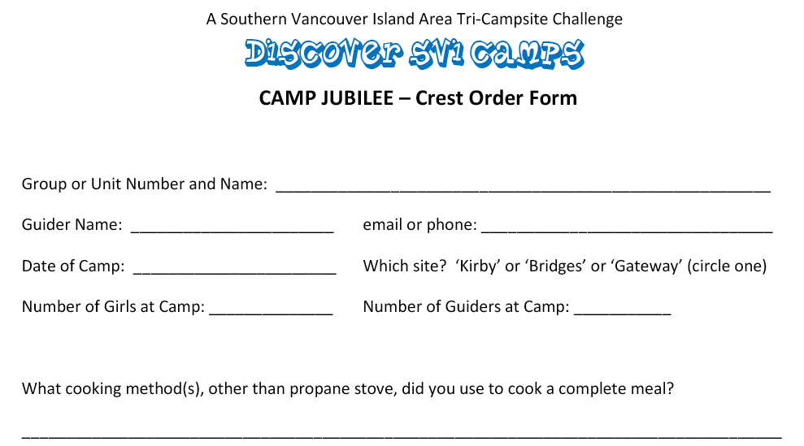
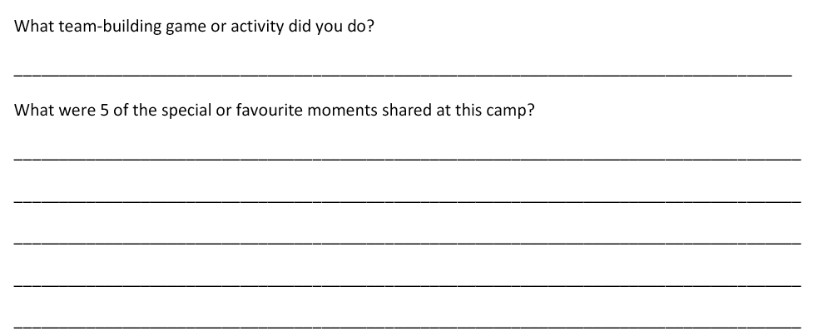

Don’t forget to submit a group photo of your entire group while at camp. We hope you had fun at camp. Please submit your form to the SVI Office
(611 Linnet Lane, Victoria, BC V9E 2B1) to claim your challenge crests.
Payment for crests is done through Unified Banking – unit to SVI Area.

Kingswood Camp – Bill Reith or Freeman King Site
Recommended for Guide age and older. Can be adapted for Embers tenting.

Prior to Camp: Contact the SVI Properties Booking or the site caretaker to obtain a list of simple service projects you may choose from at camp. Please note: If your unit chooses to cut Daphnia, an invasive plant found at Kingswood, it is poisonous. Everyone should wear gloves while cutting and handling the plants. Wash your hands thoroughly after your service to prevent contamination.

At Camp:
- Sleep in tents for a minimum of two consecutive nights at one of the tents sites at Kingswood Camp. Girls should sleep in a tent with their patrol.
- Walk around the campsite to see Freeman King site, Bill Reith Site and McKevitt Lodge. What are the stories behind the names for each of those sites? Read the stories in the information handout. The information handout and maps are located in the Kingswood kiosk.
- The water for this camp comes from a well. It is located on the road near the upper site. The treatment facility to make that water potable, is in a small building with a dome on top located near the road to the upper tent site. Go to the well location. What actions can campers take to help keep the water clean and safe to drink?
- Walk along a portion, of the park trail around the lake(s).
- Sit quietly in a spot at camp for 10 minutes. What animals do you see or hear?
- Find 3 plants growing on site that were used by First Nations and learn what they were used for. Check the hand out on plants for clues.
- Build something useful or fun with sticks found at camp or ropes you have brought to camp with you or a combination of ropes and sticks together. The whole group does not need to build the same thing. Use your imaginations.
- Play a night game in the dark or do a night activity.
- All together, sing an action song at campfire in the evening.
- Each write one thought or draw a picture of a favorite or special moment at this camp to share with your fellow campers.

After Camp:

Return the Challenge handout to where you found it. Complete the challenge form and submit it along with a picture of your group at camp to the SVI Office at
611 Linnet Lane, Victoria, BC V9E 2B1
Payment for crests is done through Unified Banking – unit to SVI Area.

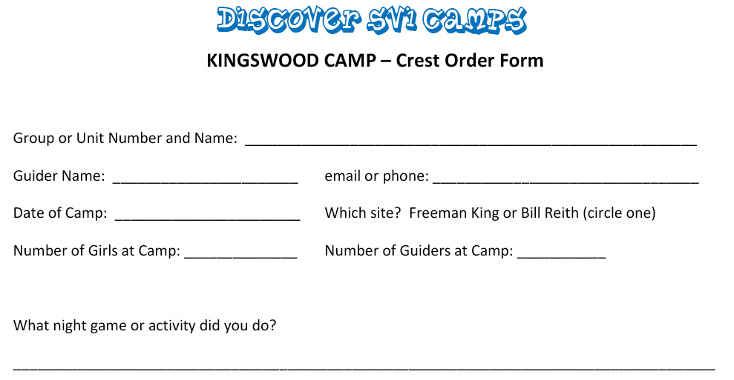
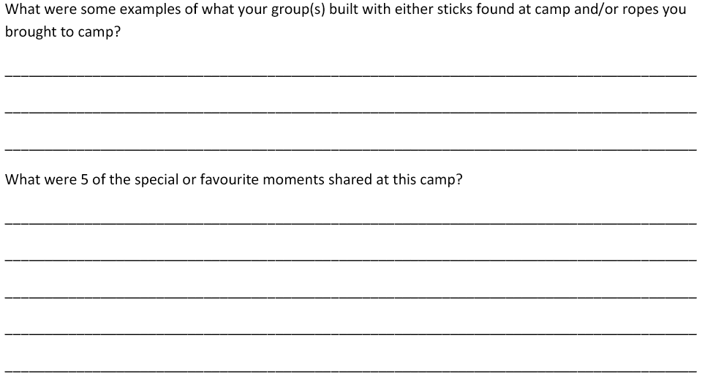

Don’t forget to submit a group photo of your entire group while at camp. We hope you had fun at camp. Please submit your form to the SVI Office
(611 Linnet Lane, Victoria, BC V9E 2B1) to claim your challenge crests.
Payment for crests is done through Unified Banking – unit to SVI Area.

Discover SVI Camps Challenge – Milne’s Landing
(Revised October 2017)

Challenge is open to all members who attend camp. Sparks and Embers please do challenges #1 – 8, Guides and older challenges #1 – 10.

- Sleep for two consecutive nights at either cabin.

- Find out how long Girl Guides of Canada – Guides du Canada has owned Milne’s Landing Camp. What is different about the clothing the Leaders ore then and the clothing the Leaders wear now?

- Walk down onto the estuary (grassy area near river). What did you see hear and smell there? Collect ideas from everyone and create a list.

- Make a craft to attach to your camp hat.

- Help with some mealtime chores.

- Play an outdoor game or activity for at least 15 minutes.

- Leaders or older girls set up an “Un-Nature Trail of at least 20 items for the other girls to follow. Remember to remove all the materials once everyone has followed the trail.

- Listen to a story about Nature or Friendship.

- Draw a picture or write about a favorite moment at camp, then share it with the group if you are comfortable doing so.

- Guide aged and older only: Remember what it was like to be an Ember at camp or a previous camping experience at this camp. What made the camp special and what happened that made you feel like you accomplished something? With all this in mind, create a camp itinerary. You may work in groups of up to 6.

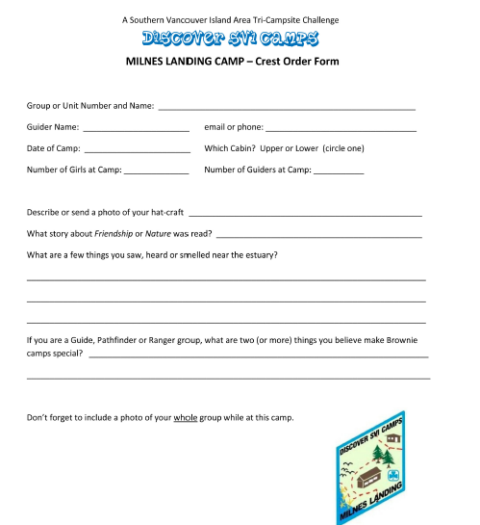

Don’t forget to submit a group photo of your entire group while at camp. We hope you had fun at camp. Please submit your form to the SVI Office
(611 Linnet Lane, Victoria, BC V9E 2B1) to claim your challenge crests.
Payment for crests is done through Unified Banking – unit to SVI Area.

